|  |  |
| --- | --- |
| Macintosh HD:Users:platypus2:Desktop:EVIM_Office.png | Document Guidelines on Setting up FlySpeed |

[Introduction 3](#_Toc505783376)

[Install and configure FlySpeed SQL query tool 3](#_Toc505783377)

[How to obtain the ODBC drivers and FlySpeed software from the Helpdesk? 3](#_Toc505783378)

[ODBC drivers: 3](#_Toc505783379)

[FlySpeed install 3](#_Toc505783380)

[How to create the correct DSNs for DEV/UAT/PROD instances of CIS? 3](#_Toc505783381)

[Connect FlySpeed to the Cisco Information Server 3](#_Toc505783382)

[How to create the corresponding 'connections' in FlySpeed? 6](#_Toc505783383)

[How to configure the connections to correctly display catalogs, schemas, and other elements? 14](#_Toc505783384)

# Introduction

FlySpeed is a general purpose query tool that is compatible with most popular databases, such as Microsoft SQL Server and CISCO. It provides structure that will be welcome to those who are new to SQL, as well as to those who are SQL experts.

# Install and configure FlySpeed SQL query tool

## How to obtain the ODBC drivers and FlySpeed software from the Helpdesk?

The Helpdesk has access to all ODBC/JDBC drivers, they are in the standard location: IT – Apps\Software.

## ODBC drivers:

Location:            [G:\IT - Apps\Software\Cisco\ODBC drivers\win64](file:///G:\IT%20-%20Apps\Software\Cisco\ODBC%20drivers\win64)

If you do not already have the Cisco Information Server 7.0 installed on your machine, then contact the helpdesk and let them know its location.

## FlySpeed install

Location:              [G:\IT - Apps\Software\FlySpeed SQL Query](file:///G:\IT%20-%20Apps\Software\FlySpeed%20SQL%20Query)

In order to get approved of downloading and installing the FlySpeed software from helpdesk, you need to provide a brief description of what it does and a link to download it (free version):

**Definition:** FlySpeed is a general purpose query tool for Windows to work with data and SQL queries.

**Link:** <https://www.activedbsoft.com/overview-querytool.html>

## How to create the correct DSNs for DEV/UAT/PROD instances of CIS?

## Connect FlySpeed to the Cisco Information Server

We are going to be configuring the ODBC Data Source Name/DSN using 64 bit ODBC Administration Tool in order to create a system data source in Windows Operating System for one of our databases so that we can use it in our web database processing applications.

System Data Source is going to provide a connection to the Cisco Information Server

Go to start menu and find out ODBC Data Source (64 bit), OR copy this below link in File Explorer:

C:\ProgramData\Microsoft\Windows\Start Menu\Programs\Administrative Tools

Open ODBC Data Source (64 bit). Click on System DSN, and then click on Add to create a new data source.

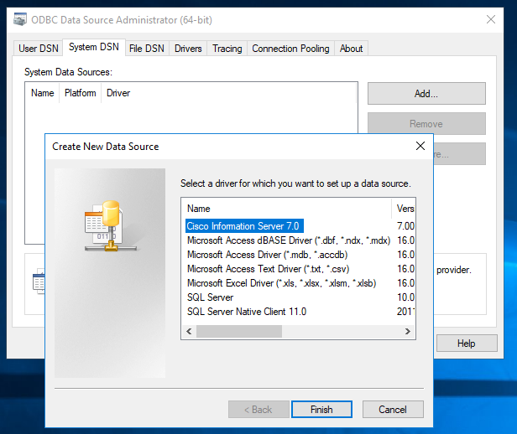

Since we are referencing to a CIS server, select Cisco Information Server as a driver.

When you click Finish, you will create the data source.

The new window pops out which allows you to configure DSN.

1. Type a name you want to give for DSN based on level you work on: either CISDEV, CISUAT, or CISPROD
2. Provide the associated host and port number
3. Choose NTLM as Integrated Authentication
4. Enter the CIS Composite Database you would like to use
5. If your concern is only to use one catalog, then you may specify it

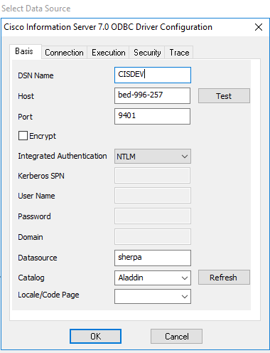

After you provide all these information, test the connection. If everything is all right, hit the ok button.

Your data source is now created

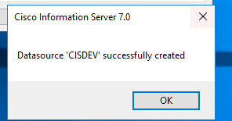

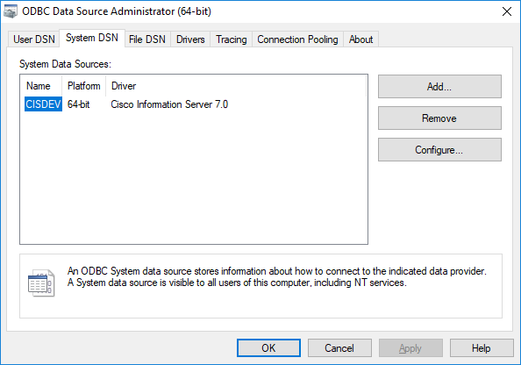

## How to create the corresponding 'connections' in FlySpeed?

1. Click on “Connection” in the upper left of FlySpeed
2. Choose “New Connection “
3. Select “Generic ADO Connection” as a Connection Type
4. Select “ANSI SQL/2003 as a SQL Syntax

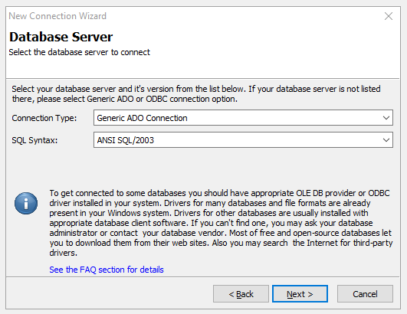

1. Once you hit Next button, now you are going to build a connection string

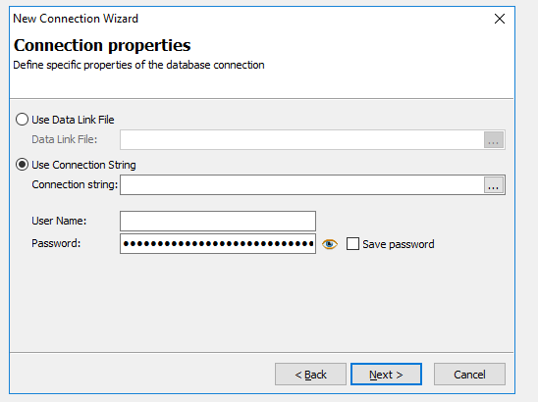

1. Click the “Build” button on the middle right

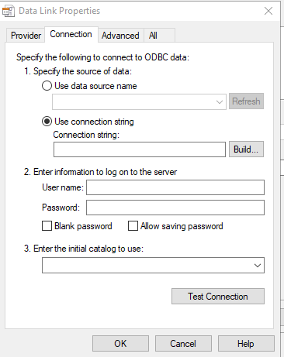

1. Hit “Machine Data Source”

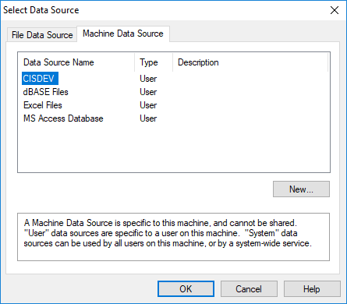

1. If you have NOT already created a CIS data source name, then click on New and follow up the previous steps above (page 3- 4)
2. Select the DSN that describes the driver you wish to connect to (CIS in this case), then hit OK

You will see this info below. Otherwise you have to fill them out again



1. Go to “Execution”, and make sure to check out the below checkboxes (Case Sensitive is essential for data source)

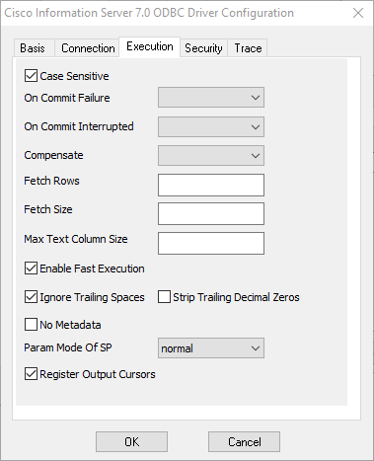

1. Once you are done, click OK to get the Connection string

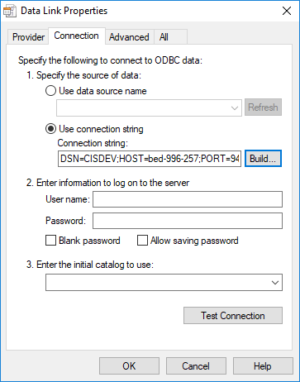

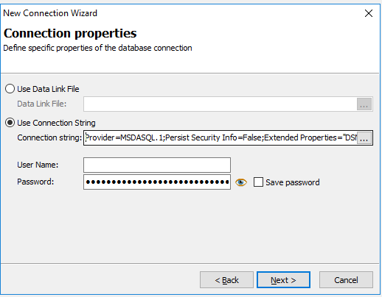

1. After you click Next, select catalogs you decide to be shown in the schema tree

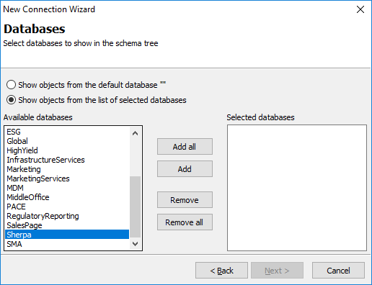

1. Click Next to specify the connection name to be shown in the Database tree

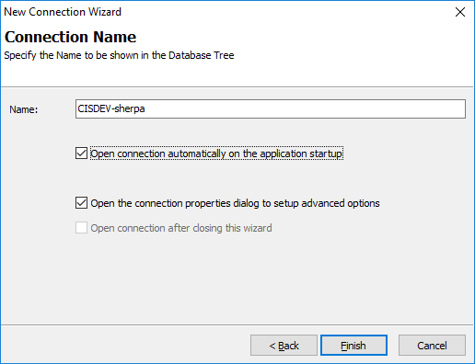

Once you hit Finish, the “Connection Properties” will pops out

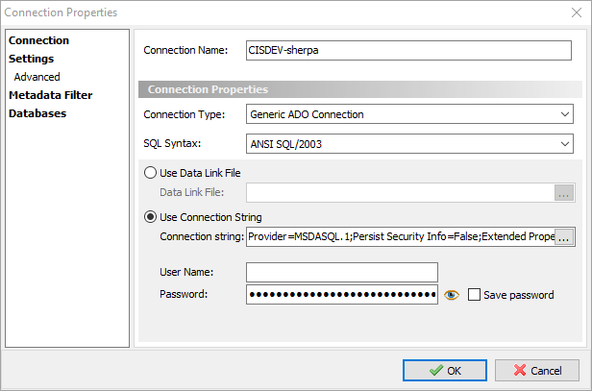

At this level, you can change:

* The Connection Name you gave it before if you would like to
* The way you connect to the data source in “Settings” (i.e. Auto connect on start-up)

In Setting Advanced (upper left corner),

* Change the default value of “Command Timeout” from 30 to 500
* Uncheck the checkbox “Hide system objects”
* Select “Don’t skip any prefixes” from the drop-down list of “Skip Name Prefixes”

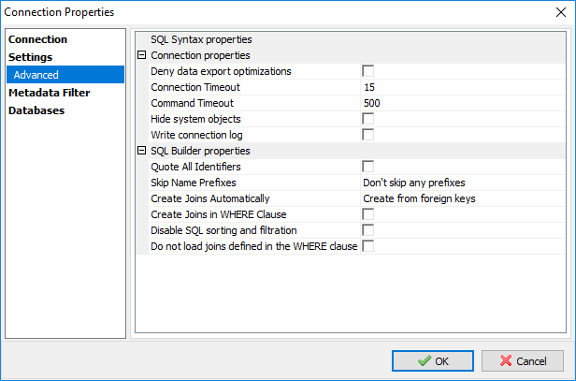

## How to configure the connections to correctly display catalogs, schemas, and other elements?

As we just did in the previous steps, you can add more than one catalogs that are in CIS Composite Database (Sherpa) by clicking “Databases” in the left corner.

For this time, my team are just concern to show objects from Aladdin and Bond catalogs (just an example)

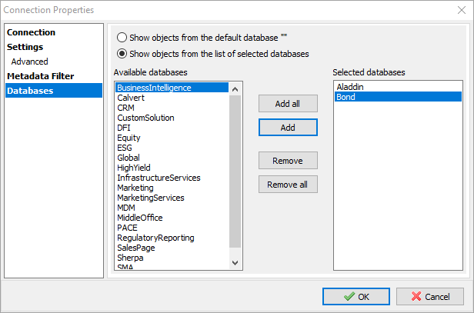

Click on Connect in the upper left of FlySpeed SQL Query window, then enter the database user credentials if they ask you for it.

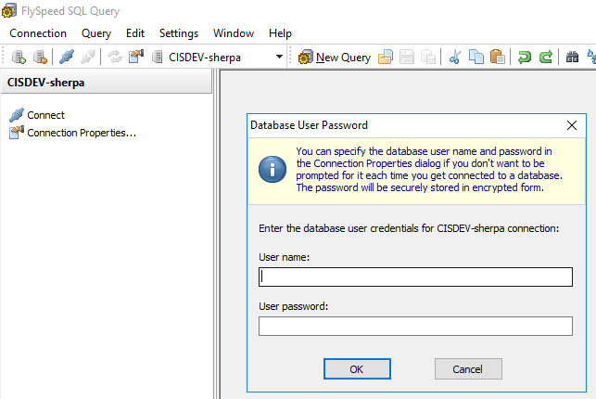

As you can see, there are all elements (Schemas and Tables) that reside inside on each catalog.

